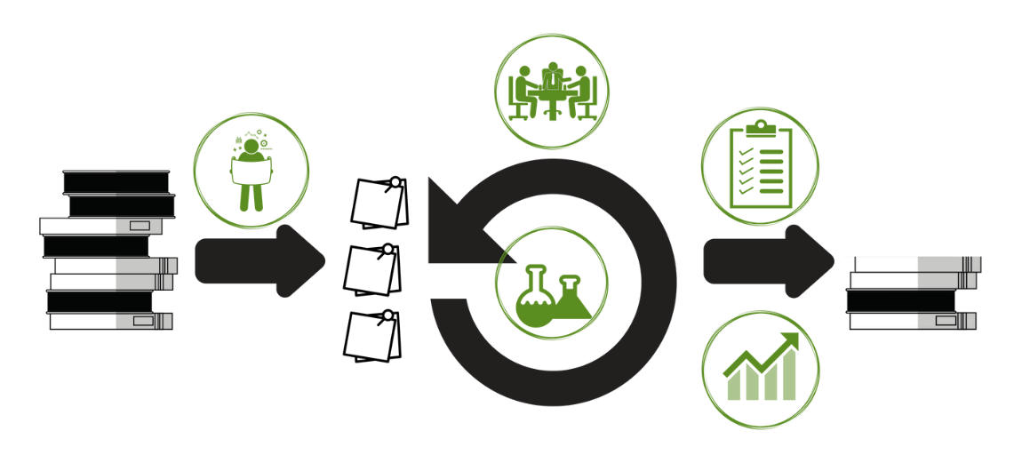

|  |  |  |
| --- | --- | --- |
| **PLANNING EXPERIMENTS** | | |
|  | **ACTIONS** | Review your pain  Agree what hurts most  Decide how to measure progress at pain reduction  Define how you will measure that  Define some experiments to try  If there are any experiments you’ve already tried, define some improvements based on their results |
| **RUNNING EXPERIMENTS** | | |
|  | **ACTIONS** | During planning, decide:  Improvement vs Experiment  Anticipated result (Metric) – replaces Acceptance Criteria with a Hypothesis  In tracking, note:  Did we finish the work?  Did the hypothesis come true? What did happen to the measures? |
| **LEADING OWNERSHIP** | | |
|  | **ACTIONS** | Meet weekly, for 7 min  Attendees: exec + team  Optional: other teams that report to the exec  Agenda:  Team: Show current data  Team: What was learned since last time?  Team: How did that insight change what we measure?  Team: Any overall changes in technical strategy  Team: Any resources we need, and on what timeline?  Exec: ask what informed any specific decision  Exec: observe and express examples of successful or non-successful ownership throughout presentation |
| **ASSESSING OWNERSHIP** | | |
|  | **ACTIONS** | Purpose: Leader needs to answer key questions to ensure teams run well.  Which teams need my help? Which teams should be left alone?  What kind of help do teams need in order to think strategically with data?  Which teams need help with owning their strategy? |
| **SHOWING IMPROVEMENT** | | |
|  | **ACTIONS** | Target measure  Experiments run  Results  Any strategy shifts (measure or experiments) for next week. Can be a discussion, depending on audience. |